GCP Generative AI - Hands-on Coding Assignment
Sathvik Putta | Virtusa Corporation
Business Scenario: GenAI-powered virtual agent for telecom billing inquiries - response generation, promise extraction, post-call notification, analytics, and monitoring.

Task 1 - Dialogflow CX: Intent & Flow
Intent: billing.inquiry.high_bill - training phrases
- Why is my bill so high this month?
- My bill went up and I don't understand why.
- I was charged more than usual; can you explain this?
- My bill went up and I don’t understand why.
- Why is my bill so high this month?
Route (pseudo-config)
route: billing_high_bill_route
condition: $intent.name = 'billing.inquiry.high_bill'
triggerFulfillment: webhook 'billing-genai-webhook', tag 'high_bill_explanation'
targetPage: Billing_Explanation_Page
Webhook / fulfillment service
The route calls a webhook fulfillment tag (high_bill_explanation) that is served by a Cloud Function (Python, Cloud Functions Gen2, HTTP trigger). Dialogflow CX passes the WebhookRequest JSON (session params, detected intent, fulfillmentInfo.tag); the function reads billing_data from the session parameters (populated earlier in the flow via a data connector to the billing system) and returns a WebhookResponse with the generated explanation text.
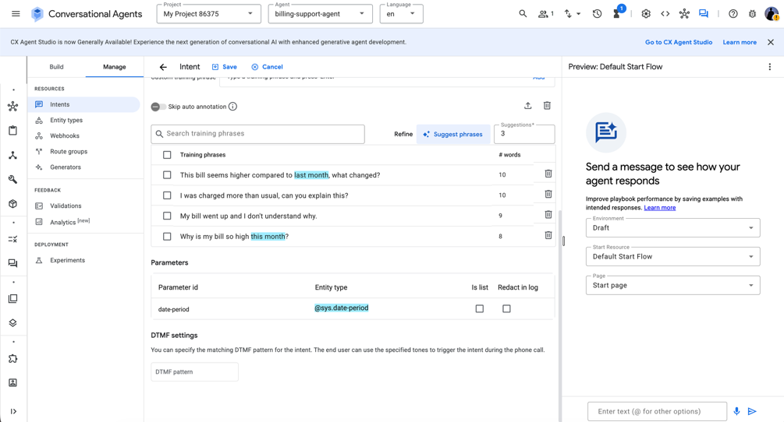
Task1_Dialogflow_Intent

Fulfillment: webhook tag routes to a Cloud Function that generates the response (Task 2).

Task 2 - Vertex AI: Generative Billing Response
Fulfillment function (pseudo-code) It calls Vertex AI's Gemini model with a grounded prompt built from the customer's actual billing_data, so the model explains rather than invents numbers:
model = GenerativeModel('gemini-1.5-flash')

prompt = f"""
Using ONLY this billing data, explain in 2-3 sentences why the bill
increased. Do not invent numbers. Previous: {prev}, Current: {curr},
New charges: {new_charges}
"""

response = model.generate_content(prompt, temperature=0.2)
return response.text

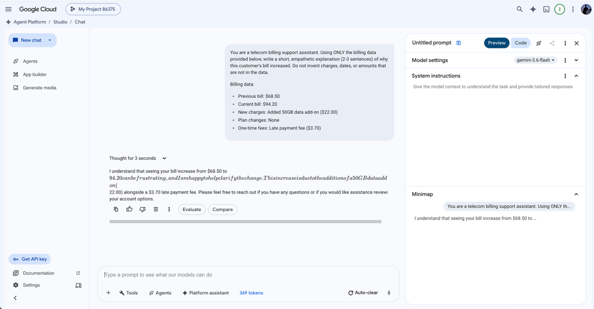

Task2_VertexAI_Response

Task 3 - Conversation Profile: Promise Extraction
Extraction prompt
Extract every refund/credit/follow-up promise from this transcript.
Return JSON array: [{promise_type, amount, timeframe, description}]
Example transcript -> expected output
Agent: I'll credit you $42, it'll post in 3-5 business days.

-> [{"promise_type": "credit",
"amount": 42.00,
"timeframe": "3 to 5 business days",
"description": "Issue a $42 credit to the account to resolve a double-billed data add- on dis"}]

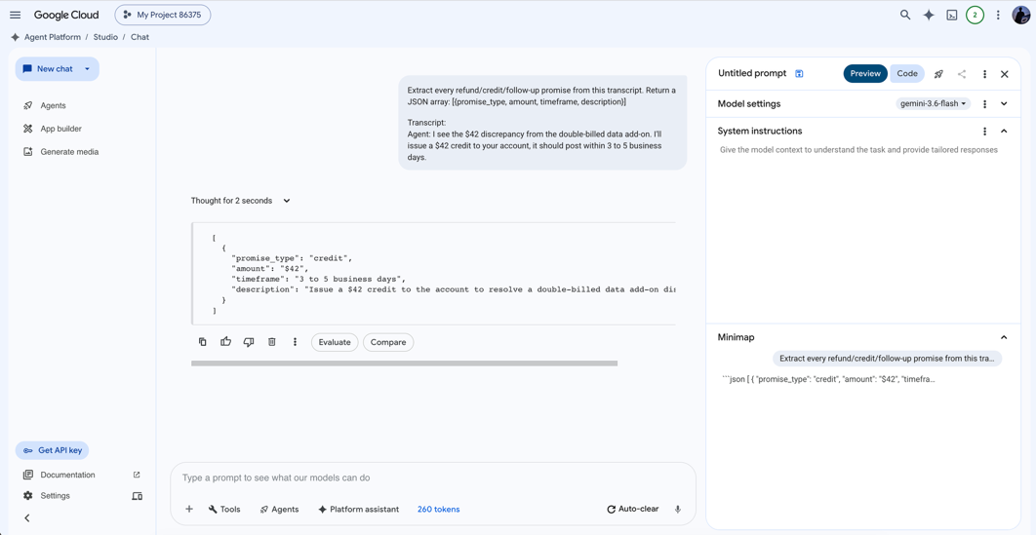

Task3_PromiseExtraction

Task 4 - Post-Conversation Email Notification

A Cloud Function is triggered by a Pub/Sub message published when Dialogflow CX (or the CCAI Insights pipeline) marks the conversation has ended. It composes the call summary and extracts promises, then sends the notification through SendGrid.
def notify_after_call(event):
data = decode(event) # call_summary, promises, stakeholder_email
body = f"Summary: {data['call_summary']}\nPromises: {data['promises']}"
send_email(to=data['stakeholder_email'], subject='Call Summary', body=body)
GCP services: Pub/Sub (conversation-ended event) triggers Cloud Functions; SendGrid/SMTP sends the email.
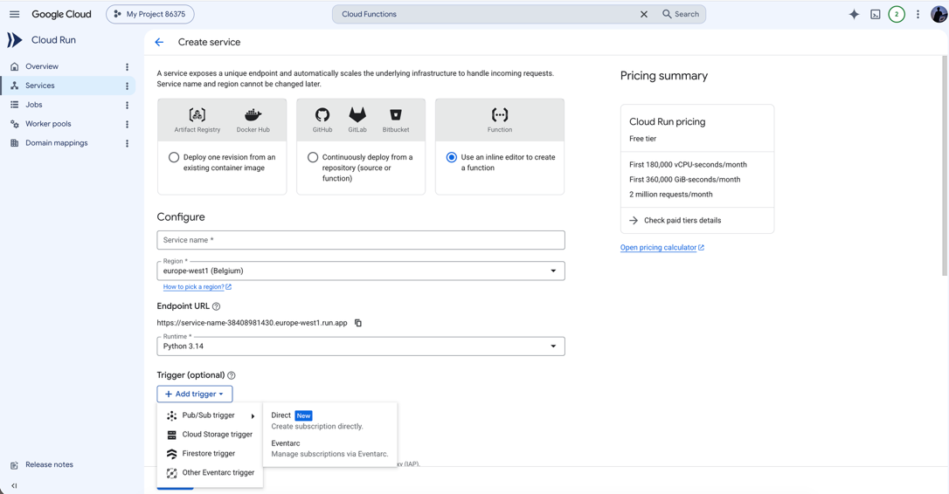
Task4_CloudFunctions_Setup

Task 5 - Conversation Insights: Analytics
Conversation data is stored in BigQuery (table: billing_conversations).
SELECT promise_type, COUNT(*) AS count, AVG(amount) AS avg_amount,
SUM(IF(fulfilled, 1, 0)) / COUNT(*) AS fulfillment_rate
FROM billing_conversations
WHERE call_date >= DATE_SUB(CURRENT_DATE(), INTERVAL 4 WEEK)
GROUP BY promise_type;
Business value: flags whether agents are promising more than the org can fulfill - an early signal of process or trust breakdown.
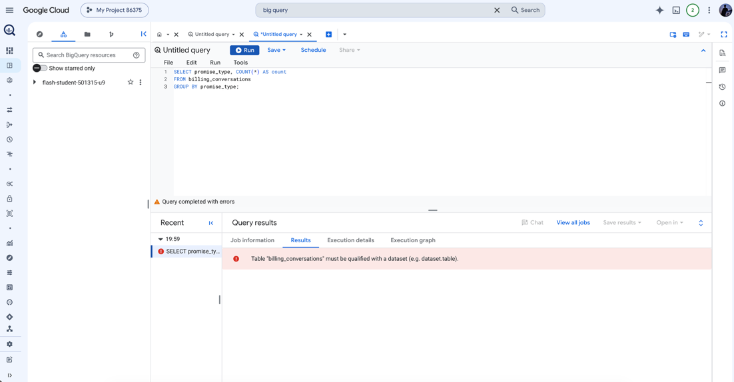
Task5_BigQuery_Query

Task 6 - Monitoring & Observability
GenAI behavior
- Cloud Logging: every Vertex AI call logs prompt, response, latency, and token counts as structured JSON log entries for audit and drift review.
- Cloud Monitoring custom metric: genai/response_confidence and genai/grounding_score (derived from response vs. billing_data match) charted over time.
System health
- Cloud Monitoring dashboards on Cloud Functions: invocation count, error rate, p95 latency, cold-start count.
- Error Reporting: automatically groups uncaught exceptions from the webhook and notification functions.
Business KPIs
- Dialogflow CX built-in analytics: containment rate, escalation rate, average handle time.
- BigQuery scheduled query feeding a Looker Studio dashboard for promise volume and fulfillment rate (from Task 5).
Alert condition
Cloud Monitoring alerting policy: if the webhook Cloud Function's error rate exceeds 5% over a rolling 5-minute window (metric: cloudfunctions.googleapis.com/function/execution_count filtered on status != 'ok'), fire a notification to the on-call Slack channel and PagerDuty. This catches Vertex AI outages or malformed billing_data before it silently degrades the customer experience.
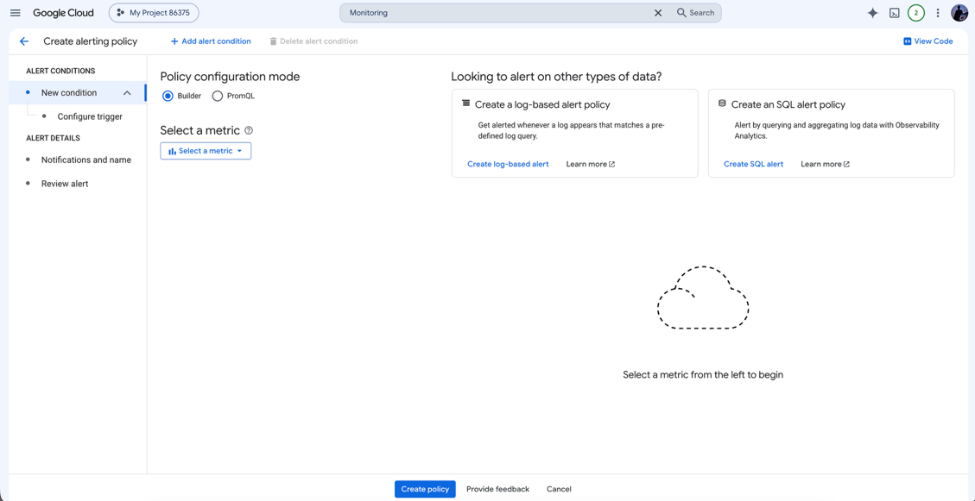
Task6_Monitoring_Alerting

Task 7 - Responsible AI Guardrails (Bonus)
- Grounding constraint (applied in the prompt, Task 2)
The prompt in Task 2 explicitly restricts the model to the billing_data provided and instructs it to say so honestly rather than invent figures when the data is incomplete. This is a prompt-level guardrail rather than a code-level filter.
Justification: hallucinated dollar amounts or dates in a billing explanation create real financial and regulatory exposure for the telecom (a customer could reasonably act on a wrong figure the bot stated). Constraining the model to only the supplied structured data keeps every generated claim traceable back to a system-of-record value.
- PII redaction before logging
import re

PII_PATTERNS = [
(r'\b\d{3}-\d{2}-\d{4}\b', '[SSN_REDACTED]'),
(r'\b(?:\d[ -]*?){13,16}\b', '[CARD_REDACTED]'),
(r'\b\d{10}\b', '[PHONE_REDACTED]'),
]

def redact(text: str) -> str:
for pattern, replacement in PII_PATTERNS:
text = re.sub(pattern, replacement, text)
return text

# applied immediately before writing to Cloud Logging / BigQuery
logging.info(redact(transcript))
Justification: transcripts and logs routinely contain account numbers, phone numbers, or card fragments read aloud by customers. Redacting before persistence keeps Cloud Logging and BigQuery exports out of PCI/PII scope and limits blast radius if logs are ever over-shared internally.
- Vertex AI safety filters
safety_settings block harassment/hate/dangerous-content categories on the generate_content call - guards against abusive transcript content leaking into the response.

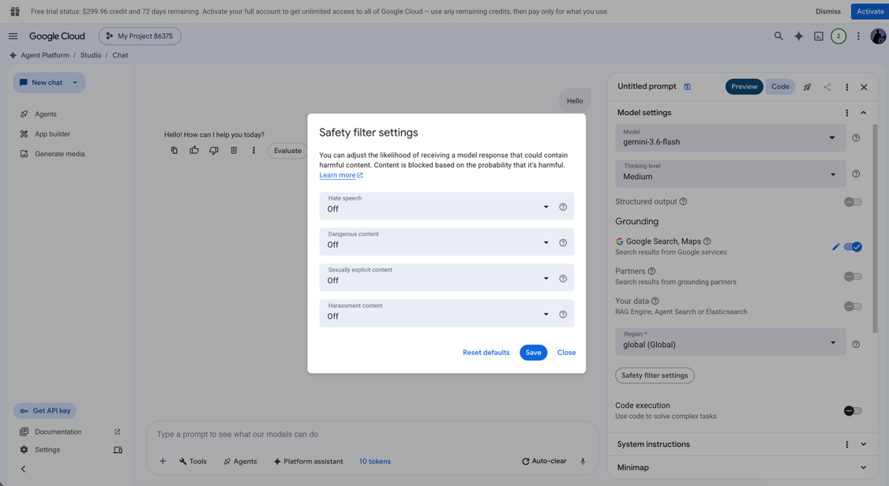
Task7_SafetySettings

